CANNED GOODS | PANTRY ITEMS | PERSONAL HYGIENE | HOUSEHOLD ITEMS
FRUIT | OIL | BODY SOAP | DISH SOAP
CHICKEN | FOLGERS COFFEE | BRUSH/COMB | ALUMINUM FOIL
SPAM | DECAF COFFEE | RAZORS | REUSEABLE BAGS
TUNA | JAM/JELLY | DEODORANT | STORAGE BAGS
VIENNA SAUSAGE | COOKIES | TOOTHBRUSH | DETERGENT PODS
GRAVY | GRITS | TOOTHPASTE | REUSABLE/GROCERY BAGS
SPINACH | PANCAKE MIX | SHAVING CREAM | KLEENEX
CHILI | SYRUP
KIDNEY BEANS | SALT
PINTO BEANS | PEPPER
 | VINEGAR
 | PICKLES
 | RELISH
 | MUSTARD
 | HOT SAUCE

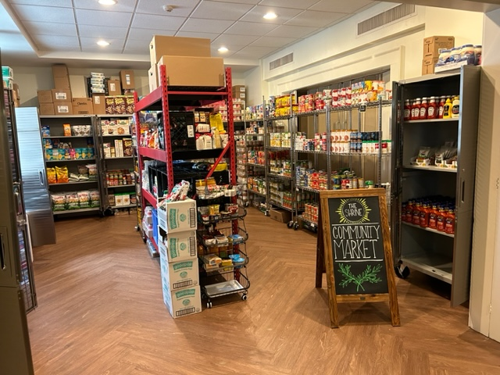
September by the numbers:
272 households
87 children
80 seniors
38 homebound persons
Frozen Items: 2,154 lbs
Pantry Items: 3,572 lbs

DROP OFF TIMES:
Sundays at Mass
Thursdays from 10-noon
Fridays from 10-2 PM

